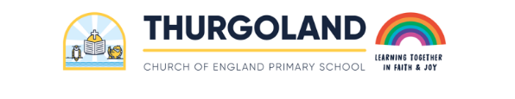
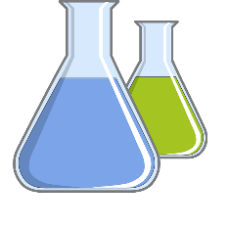
FS Scientists

The most relevant statements for science are taken from the following areas of learning:
- Communication and Language
- Physical Developmen
- Understanding the World
In Reception Class (Foundation Stage), in Communication and Language, the children will:
- Learn new vocabulary.
- Ask questions to find out more and to check what has been
said to them.
- Articulate their ideas and thoughts in well-formed sentences.
- Describe events in some detail.
- Use talk to work out problems and organise thinking and activities. Explain how things work and why they might happen.
- Use new vocabulary in different contexts.
In Reception Class (Foundation Stage), in Physical Development, the children will:
- Know and talk about the different factors that support their overall health and wellbeing:
  - regular physical activity
  - healthy eating
  - tooth brushing
  - sensible amounts of ‘screen time’
  - having a good sleep routine
  - being a safe pedestrian
In Reception Class (Foundation Stage), in Understanding the World, the children will:
- Explore the natural world around them.
- Describe what they see, hear, and feel while they are outside.
- Recognise some environments that are different to the one in which they live.
By the end of Foundation stage, a child who is attaining typically (Early Learning Goal) will be able to:
- Make comments about what they have heard and ask questions to clarify their understanding.
- Manage their own basic hygiene and personal needs, including dressing, going to the toilet, and understanding the importance of healthy food choices.
- Explore the natural world around them, making observations and drawing pictures of animals and plants.
- Know some similarities and differences between the natural world around them and contrasting environments, drawing on their experiences and what has been read in class.
- Understand some important processes and changes in the natural world around them, including the seasons and changing states of matter.
By the end of FS, a child attaining typically (Early Learning Goal) will be able to understand and use the following vocabulary:
Floating sinking experiment changes materials investigate living explore survive habitats similarities differences

